Guideline for ' Suwon city tour bus'

Hello, everyone!
Thank you for applying for “Suwon city tour bus” organized by SWCIC.
Hoping we can make a memorable time together, let me provide you with a guideline.

About ‘Suwon city tour bus
The program, ‘Suwon city tour bus is designed for foreign students of Suwon city to learn korea’s cultural heritages.

<Instruction>
- Gathering on. April 23(sat) by 13:00p.m

- Meet at Suwon City Tour Center (Suwon Station exit number 4)
※ Please refer to the map to find the place
(Address : Gyeonggi suwon city tour center, 924 duckyoungdae-ro, Paldal-gu, Suwon-si)

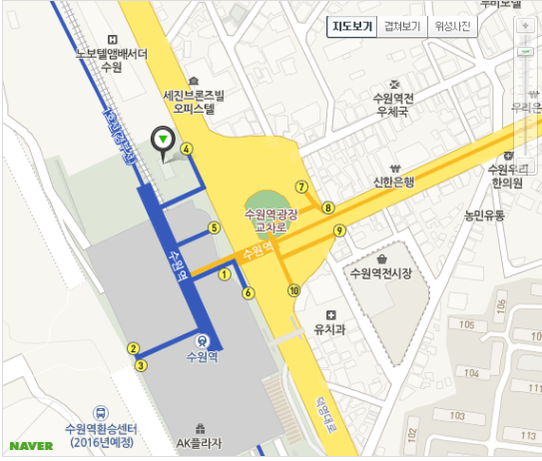

<Itinerary>
Time | Place | Contents
13:00~  14:00 | Suwon Station exit number 4 | Orientation & Ice breaking
14:00~17:00  (approximately) | Suwon city tour bus  (Haewoojae - Hwaseo gate - Hwaseong Fortress - Jangan gate - Hwahong gate - Yeonmudae - Suwon Hwaseong Museum) | Enjoy various landmarks in Suwon.  historical explanation about Suwon  see traditional martial art performance and experience Korean Archery (Guk-gung)
~17:30 | Suwon city tour center | Farewell

E-mail at scvakorera@gmail.com or call 010-4542-2275

